Output:
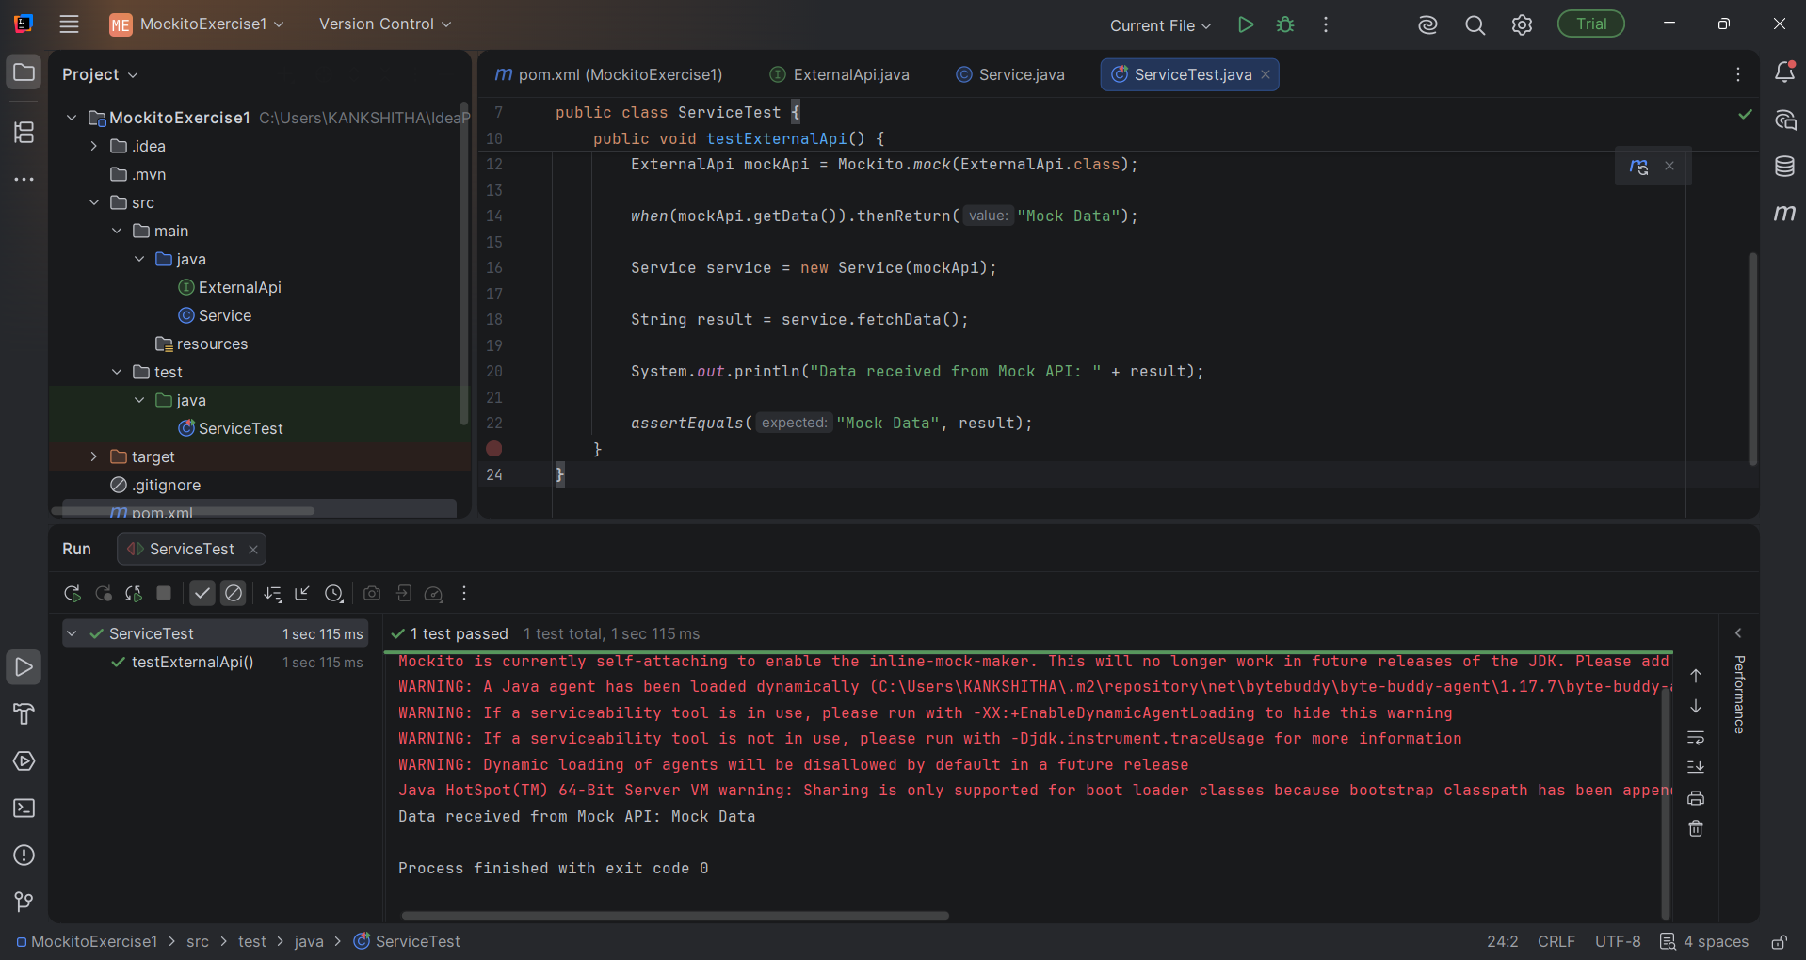

The red coloured sentences are warnings that are generated by Java 23 and Mockito. They are not program errors. The test executed successfully as output is indicated by
“Data received from Mock API: Mock Data
Process finished with exit code 0.”

